Computer quiz -3
1
Write the text named "Fishing Guide" to an empty page.

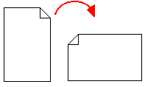

2
Change page orientation to Landscape.

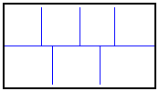
3Divide the page to 2 sections as shown in the figure. (Section one: 4 columns and Section two: 3 columns.)

- 4Write school name and your class as the header.
Example: M4 @ Fatih High School
- Write your name as the footer.

5
Insert one clipart to your page, as it is in the worksheet.

6
Format the first letter of the title as it is in the worksheet.

7
Change the color of the line under the title to blue.

8
SAVE YOUR FILE to
C:\My Documents\QUIZ4-YourName

GOOD LUCK !

